Introductory report, EMG-Device

[521159P Principles of Digital Fabrication](https://wiki.oulu.fi/display/DIGIFAB/521159P+Principles+of+Digital+Fabrication+Home)

DIGIFAB10

The idea is to build a device that can measure EMG signal. EMG signals are created when muscles are used, and nerve impulses are sent. Impulses create a potential difference in the order of 1-10mV which is amplified, filtered and read with an Arduino. To meet course requirements an enclosure will be 3D printed and something laser cut. We arrived at the idea of an EMG device as a combination interest to the subject of bio signals, the challenge and courses about op amps are running in parallel with this course, so we can use in practice what we have learned.

Other project that we thought of was an Arduino tank that could locate WIFI signal sources, but this would have been very software heavy, and because we are EE students, we wanted to put emphasis on hardware. Also locating sources turns out to be very hard. Our back up plan is an EKG device, which instead of 3 measuring lanes, uses only one.

BOM:

|  |  |  |  |  |  |
| --- | --- | --- | --- | --- | --- |
| **QTY** | **Component type** | **Package** | **Source** | **Price(eur)** | **URL** |
| 10 | 0.1uF capacitor | 1206 | Electronics club | 0 |  |
| 1 | 1uF capacitor | 0603 | Johannes | 0 |  |
| 1 | 12nF capacitor | 0603 | Johannes | 0 |  |
| 1 | 20nF capacitor | 0603 | Johannes | 0 |  |
| 3 | 47uF capacitor | 5x5mm | Johannes | 0 |  |
| 1 | 47pF capacitor | 0603 | Johannes | 0 |  |
| 2 | 10uF tant. Cap. | 1206? | Electronics club | 0 |  |
| 2 | SMD LED | 0603 | Johannes | 0 |  |
| 2 | 1N4148W-F, SMD diode | SOD-123 | Mouser | 0,3 | https://www.mouser.fi/ProductDetail/Diodes-Incorporated/1N4148W-7-F?qs=sGAEpiMZZMvilazpv%252bFqvbevgE8TPEOt |
| 1 | 3 pin header | male 100mil header | Electronics club | 0 |  |
| 1 | 3 screw terminal | 5mm terminal | Johannes | 0 |  |
| 1 | 2 screw terminal | 5mm terminal | Johannes | 0 |  |
| 2 | 1MOhm resistor | 0603? | Electronics club/Johannes | 0 |  |
| 1 | 470 Ohm resistor | 0603 | Johannes | 0 |  |
| 2 | 82kOhm resistor | 0603 | Johannes | 0 |  |
| 2 | 120kOhm resistor | 0603 | Johannes | 0 |  |
| 5 | 10kOhm resistor | 0603 | Johannes | 0 |  |
| 1 | 4,7kOhm resistor | 0603 | Johannes | 0 |  |
| 5 | 1kOhm resistor | 0603 | Johannes | 0 |  |
| 1 | 0 Ohm resistor | 0603 | Johannes | 0 |  |
| 1 | 15kOhm resistor | 0603 | Johannes | 0 |  |
| 1 | 100kOhm resistor | 0603 | Johannes | 0 |  |
| 2 | DIP8 socket | DIP8 | Johannes | 0 |  |
| 1 | DIP14 socket | DIP14 | Johannes | 0 |  |
| 1 | DIP28 socket | DIP28 | Johannes | 0 |  |
| 1 | MAX1720 charge pump | TSOP-6 | Mouser | 0,58 | https://www.mouser.fi/ProductDetail/ON-Semiconductor/MAX1720EUTG?qs=sGAEpiMZZMtitjHzVIkrqdfdkrf0Qy0Qzg%252b1DRXikVE%3d |
| 1 | HC-05 BT unit | custom | Johannes | 0 |  |
| 1 | INA121PA inst. amp. | DIP8 | Mouser | 4,94 | https://www.mouser.fi/ProductDetail/Texas-Instruments/INA121PA?qs=sGAEpiMZZMsE1dKaA2ImUPh%2fgv48%2feoeALcGDSe487k%3d |
| 1 | TL072IP op. Amp. | DIP8 | Mouser | 0,56 | https://www.mouser.fi/ProductDetail/Texas-Instruments/TL072IP?qs=5BZzbFV4k2v7IBrcArRPQw== |
| 1 | LM324N | DIP14 | Mouser | 0,43 | https://www.mouser.fi/ProductDetail/Texas-Instruments/LM324N?qs=sGAEpiMZZMtCHixnSjNA6Araa3jp4DVB37ZJv3RooEc%3d |
| 1 | ATMega 328p | DIP28 | Electronics club | 0 |  |
| 1 | LM1117 3.3V regulator | TO252 | Electronics club | 0 |  |
| 8 | button things | button | Johannes | 0 |  |
| 50 | Electrodes, 34mm | button | Medkit.fi | 14,26 | https://www.medkit.fi/ambu-blue-sensor-m-oo-s?___store=finland&nosto=frontpage-nosto-1 |

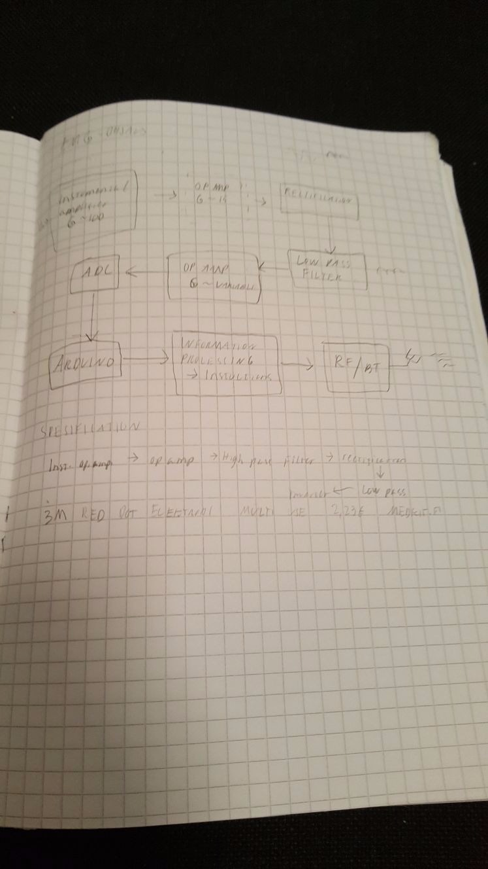

the original sketch

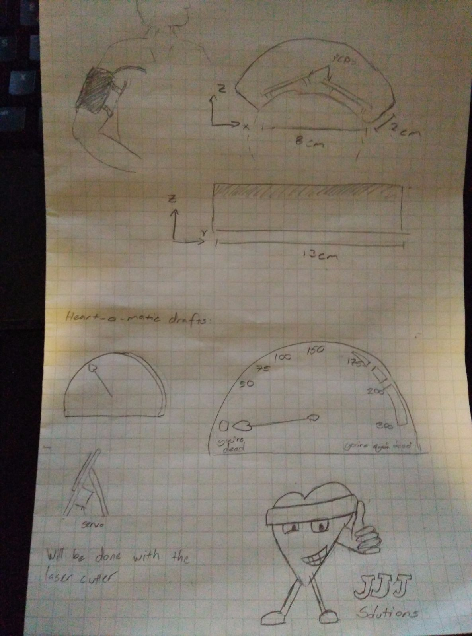

sketch

